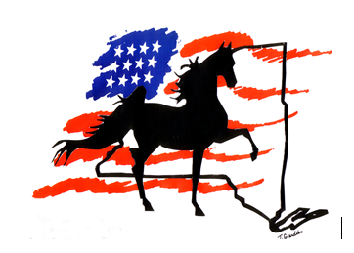

**Syracuse International Horse Show 2025**

**June 25– June 28, 2025**

**BUSINESS NAME:___________________________________________________________________**

**ADDRESS:__________________________________________________________________________**

**TELEPHONE:________________________ EMAIL:______________________________________**

Rental Space Requested (mark one)

Main Barn: __________ Per Stall* $140.00 (only 6 available)

Coliseum: __________ Reasonable area $300.00

Outdoor: __________ $.02 per square foot + $100 (including awnings)

[Note: All Display Areas will be measured.]

**Main Barn stalls are approximately 8’ x 10’. This includes use of inside area of stall and not more than three (3) feet in front of stall, not exceeding the 10-foot wide area in front of stall; doors will remain flat against stall fronts. Should you require more space, it is recommended that additional stalls be ordered. Tables are available at the Office. These rules will be strictly enforced as Vendor Area must provide optimum flow of shoppers while maintaining a safe walkway.**

**We are looking forward to seeing all of you. We are expecting a larger number of Vendors this year. Please send this Vendor Contract ASAP.**

Vendor Signature_______________________________________

NYS Sales Tax ID Number_______________________________

Please return contract by June 1, 2025 or email TeeMagic@aol.com

Theresia Giardino

Syracuse International Horse Show

17 Crest Hill Drive

Whitesboro, NY 13492

(315) 723-7737

**SYRACUSE INTERNATIONAL HORSE SHOW IS NOT RESPONSIBLE FOR ANY FORM OF SECURITY, LOST, STOLEN, OR DAMAGED GOODS.**